# Basic Tools

## Purpose

This module offers the following set of functions:

* [Spatial statistics (batch)](#_Spatial_Statistics_(Batch))
* Model performance
* Classify R2
* Extract by time
* Detect burnt periods
* Import netCDF

## Installation

Install the .sav files in the save_add folder (see also [ENVI .sav files: Installation and configuration](http://www.itc.nl/personal/nieuwenh/installations.html).

_nrsmenu.sav Define NRS menu item in ENVI

nrs_Utils.sav Library with utility routines

nrs_basic_tools.sav The actual software

## Usage (gui)

|  |  |
| --- | --- |
| nrs_statistics_batch_gui | Start the user interface of the spatial statistics (batch) |
| nrs_model_perf_gui | Start the user interface of the model performance |
| nrs_classify_r2_gui | Start the user interface of the R2 classification |
| nrs_extract_time_gui | Start the user interface of the extract by time function |
| nrs_detect_burnt_gui | Start the user interface of the burnt period detection |

Alternatively the command can be started from the ENVI menu: ‘NRS | Spatial statistics (batch):

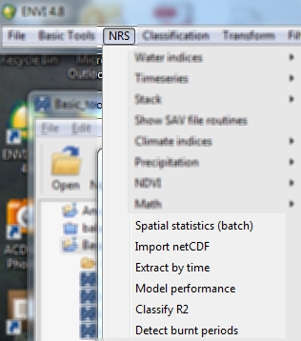

### Spatial Statistics (Batch)

Menu option is ‘NRS | Spatial statistics (batch), the command line is ‘nrs_statistics_batch_gui’. This function accepts a series of input images and processes each input image separate to calculate the spatial statistics. It calculates: minimum, maximum, mean and standard deviation.

The software either accepts a file list in a text file or a folder name where the files to process are located. In case of the text file: each line contains the name of a single band image with a fully specified path. If the folder option is chosen, make sure that only images are located here; other files will cause problems

Below is the user interface:

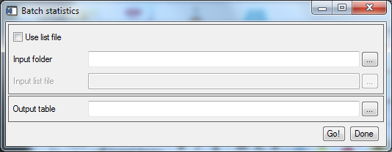

Explanation of all the fields:

|  |  |
| --- | --- |
| Use list file | Toggle between the list-file or folder option |
| Input folder | Select the folder where all images are located |
| Input list file | Select a text file with one image on each line (for example see below) |
| Output table | The name of the file to store the results of the statistics |

#### Example list file

E:\NRS\data_folder\batch_in\file1.dat

E:\NRS\data_folder\batch_in\file2.dat

E:\NRS\data_folder\batch_in\file3.img

E:\NRS\data_folder\batch_in\file4.img

Note: ENVI files are accompanied by .HDR files; these header files should **not** be in the list file!

#### Example output table

filename,min,max,mean,stdev

file1.dat,0.00000,0.603201,0.300600,0.12000

file2.dat,-1.02260,-1.02260,-1.02260,0.23000

file3.img,-0.42857,-0.42857,-0.42857,0.20560

file4.img,-1.00000,-1.00000,-1.00000,0.00000

### Model performance

Menu option is ‘NRS | Model performance, the command line is ‘nrs_model_perf_gui’. This function calculates performance indices from observation data and model predicted data. The observation data and the estimations are expected in raster format and can be single band or multiband. Model performance is calculated for each location. The indices to be calculated are user defined. The possible indices are taken from (Chiti, Papale et al. 2010):

* RMSE (root mean square error)
* EF (model efficiency) / R2
* CD (coefficient of determination)
* E (relative error)
* MRE (mean relative error)
* MD (mean difference)

Note that R2 is also called coefficient of determination, but CD is calculated differently!

The output in case of multiband inputs is a raster image containing one band for each selected index. The observations and model predictions are evaluated at each location; both are considered vectors of data.

In the single band case the output is a table; for an example see below.

Below is the user interface:

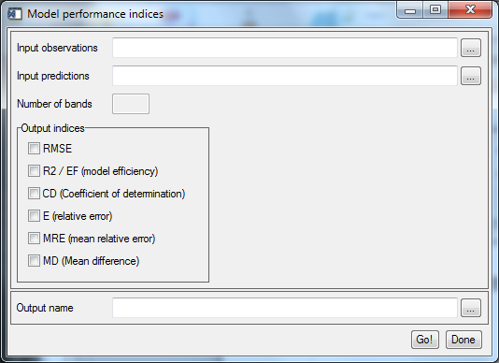

Explanation of all the fields:

|  |  |
| --- | --- |
| Input observations | The original observations |
| Input predictions | The predictions from the model |
| Number of bands | Read only field indicating the number of bands in the observations |
| Output indices | Checkboxes to select the indices that should be calculated |
| Output name | The name of the output; the software suggest a default based on the input observations name. |

#### Used formulas

$RMSE=\sqrt{\frac{1}{n}\sum_{i=1}^{n}{{\left(P_{i}-O_{i}\right)}^{2}}}$ (1)

$EF=R2=\frac{\sum_{i=1}^{n}{{\left(O_{i}-\overline{O}\right)}^{2}}-\sum_{i=1}^{n}{{\left(P_{i}-O_{i}\right)}^{2}}}{\sum_{i=1}^{n}{{\left(O_{i}-\overline{O}\right)}^{2}}}$ (2)

$CD=\frac{\sum_{i=1}^{n}{{\left(O_{i}-\overline{O}\right)}^{2}}}{\sum_{i=1}^{n}{{\left(P_{i}-\overline{O}\right)}^{2}}}$ (3)

$E=\frac{100}{n}\sum_{i=1}^{n}{\frac{\left(O_{i}-P_{i}\right)}{O_{i}}}$ (4)

$MD=\frac{1}{n}\sum_{i=1}^{n}{\left(P_{i}-O_{i}\right)}$ (5)

$MRE=\frac{100}{n}\sum_{i=1}^{n}{\left|\frac{O_{i}-P_{i}}{O_{i}}\right|}$ (6)

#### Example output table

Observed: E:\NRS\nov1901_1 ; The filename of the observations

Predicted: E:\NRS\nov1942_1 ; The filename of the predictions

RMSE: 251.748

R2/EF: 0.895061

CD: 0.981515

E: -28.9394

MRE: 38.7408

MD: 3.54594

#### References

Chiti, T., D. Papale, et al. (2010). "Predicting changes in soil organic carbon in mediterranean and alpine forests during the Kyoto Protocol commitment periods using the CENTURY model." Soil Use and Management **26**(4): 475-484.

### Classify R2

Menu option is ‘NRS | Classify R2, the command line is ‘nrs_classify_r2_gui’. This function classifies the output of the R2 model performance into one of five classes:

|  |  |
| --- | --- |
| R2 Value | Class |
| 0.0 to 0.2 | No fit |
| 0.2 to 0.4 | Very poor fit |
| 0.4 to 0.6 | Poor fit |
| 0.6 to 0.8 | Good fit |
| 0.8 to and including 1.0 | Excellent fit |

Other values are considered unclassified.

Below is the user interface:

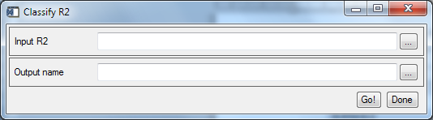

Explanation of all the fields:

|  |  |
| --- | --- |
| Input R2 | The image with the R2 values; In case of multi-band input: the software expects the R2 values in the first band of the image. |
| Output name | The name of the output; the software suggest a default based on the input observations name. |

### Extract by time

Menu option is ‘NRS | Extract by time, the command line is ‘nrs_extract_time_gui’. This function calculates performance indices from observation data and model predicted data. The observation data and the estimations are expected in raster format and can be single band or multiband. Model performance is calculated for each location. The indices to be calculated are user defined. The possible indices are taken from (Chiti, Papale et al. 2010):

The output in case of multiband inputs is a raster image containing one band for each selected index. The observations and model predictions are evaluated at each location; both are considered vectors of data.

In the single band case the output is a table; for an example see below.

Below is the user interface:

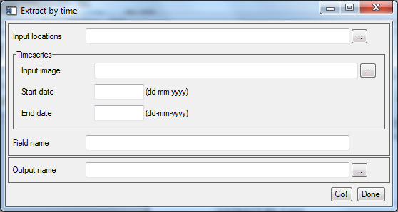

Explanation of all the fields:

|  |  |
| --- | --- |
| Input observations | The original observations |
| Input predictions | The predictions from the model |
| Number of bands | Read only field indicating the number of bands in the observations |
| Output indices | Checkboxes to select the indices that should be calculated |
| Output name | The name of the output; the software suggest a default based on the input observations name. |

### Detect burnt periods

Menu option is ‘NRS | Detect burnt periods, the command line is ‘nrs_detect_burnt_gui’. This function determines the periods in the time series where the area ratio is less than a provided threshold. The threshold can be fixed (a single value) or taken from a time series column in the input table.

The function offers an additional option to handle noise around the threshold in the time series ratios.

The function creates two output files:

1. Flag file: A table file with the detected burnt periods.
2. Per file: A table file containing a list of periods when burnt periods are detected.

Below is the user interface:

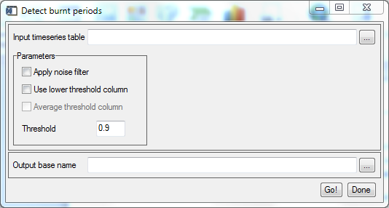

Explanation of all the fields:

|  |  |
| --- | --- |
| Input timeseries table | The input table with the time series data |
| Apply noise filter | Handle noise in the ratios around the threshold |
| Use lower threshold column | Use the threshold value in the time series data |
| Average threshold column | Use a single value by averaging the threshold data from the table |
| Threshold | The user specified threshold; is overruled when the use lower threshold column option is checked |
| Output name | The base name of the output. |

#### Example input file

Pair_ID,Upper band,Lower band,31,32,33,34

1-4-1998,1.03241,0.97763,0.96250,1.13445,1.17241,1.07895

11-4-1998,1.02863,0.98074,1.04706,1.18548,1.28689,1.15033

21-4-1998,1.03237,0.97265,0.97000,1.14184,1.32558,1.09942

1-5-1998,1.02326,0.98214,0.97959,1.17600,1.19084,1.11111

11-5-1998,1.02973,0.98817,0.97321,1.10345,1.09028,1.01705

21-5-1998,1.01819,0.99285,1.00000,1.03289,1.11644,1.03409

1-6-1998,1.01606,0.99166,0.96774,0.97093,0.94915,1.02162

11-6-1998,1.01287,0.99420,1.01212,0.97207,0.96610,1.03109

Note that the date column is immediately followed by both threshold columns. This is important because the function expects the data in that order.

#### Example output files

Flag file: The name is constructed from the base output name by appending the postfix of ‘_flag’. This file is organized the same way as the input table, with the exception that the threshold columns are left out. The value now represent the detection of burnt period (value = 1).

Pair_ID,31,32,33,34,35,36,37,38

1-4-1998,0,0,0,0,0,0,0,0

11-4-1998,0,0,0,0,0,0,0,0

21-4-1998,0,0,0,0,0,0,0,0

1-5-1998,0,0,0,0,0,0,0,0

11-5-1998,0,0,0,0,0,0,0,0

Per file: The name is constructed from the base output name by appending the postfix of ‘_per’. This table contains one record for each detected burnt period. Note that there can be more than one period for each of the input columns.

The columns have the following meaning:

|  |  |
| --- | --- |
| Column name | Description |
| Pair_ID | The identifier of the input column |
| start | The index of the start of a burnt period |
| end | The index of the end of a burnt period |
| #periods | The length of the period |
| start_date | The start date of the burnt period |
| end_date | The end date of the burnt period |
| #days | The number of days from burning to recovery |

Pair_ID,start,end,#periods,start_date,end_date,#days

32,17,18,2,21-9-1998,1-10-1998,10

32,338,342,5,21-8-2007,1-10-2007,41

32,412,413,2,11-9-2009,21-9-2009,10

32,482,487,6,21-8-2011,11-10-2011,51

32,518,519,2,21-8-2012,1-9-2012,11

32,521,523,3,21-9-2012,11-10-2012,20

33,15,16,2,1-9-1998,11-9-1998,10